Assignment Day4

Q1.Print Hello World

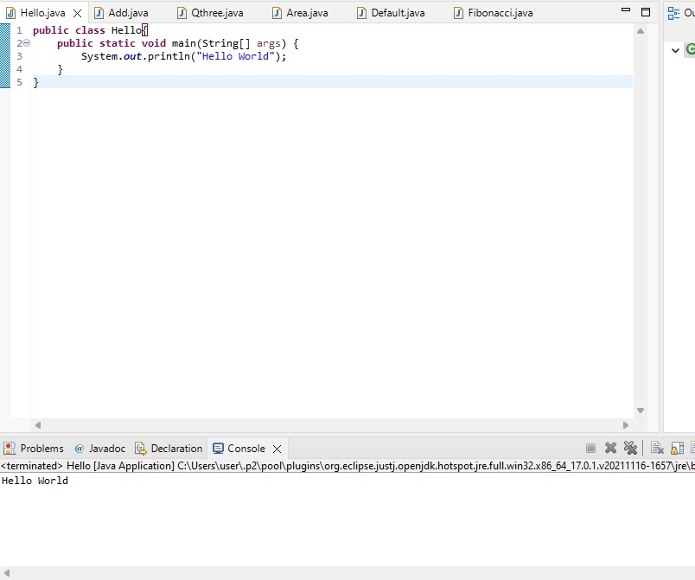

Q2. Add two numbers/binary numbers/characters

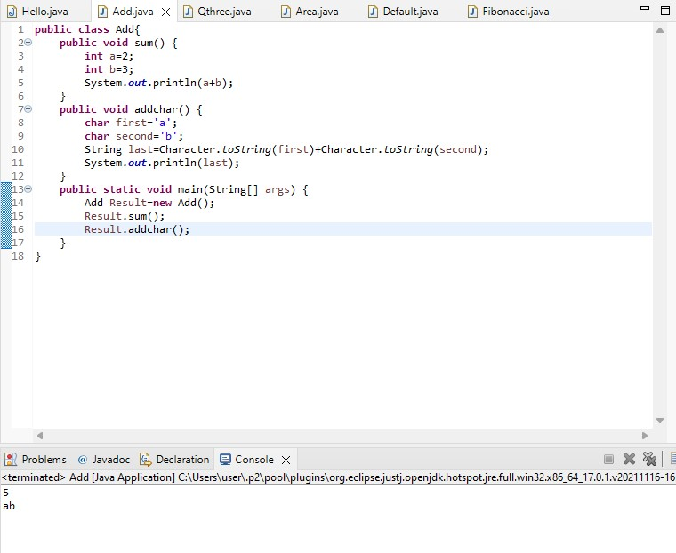

Q3. Calculate compound interest Calculate the power of a number Swap two numbers

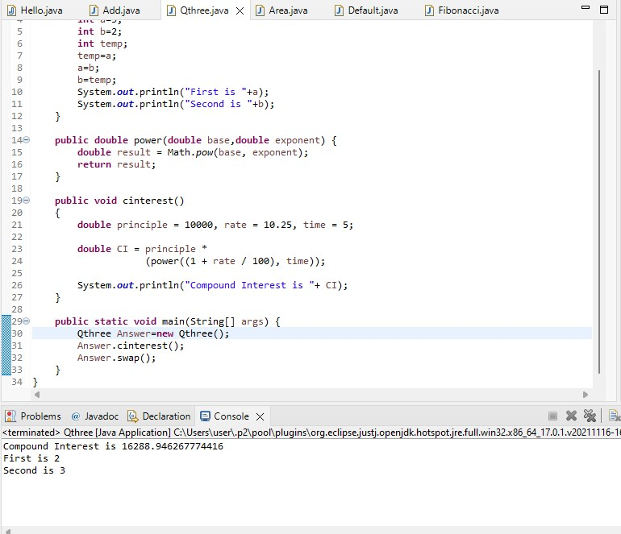

Q4. Calculate the area of rectangle Calculate area and circumference of a circle using multiple classes Java program to find ASCII value of a character

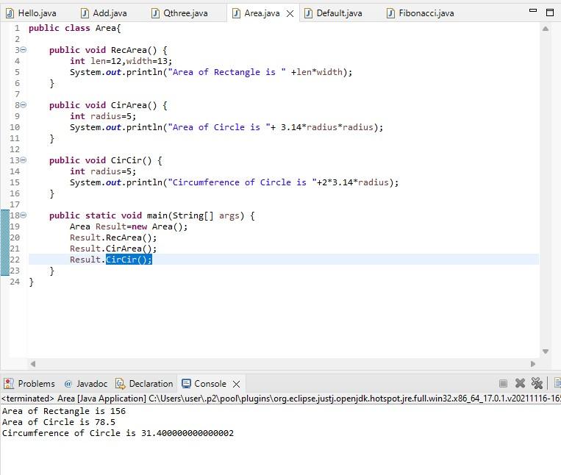

Q5. Print default values of primitive data type variable

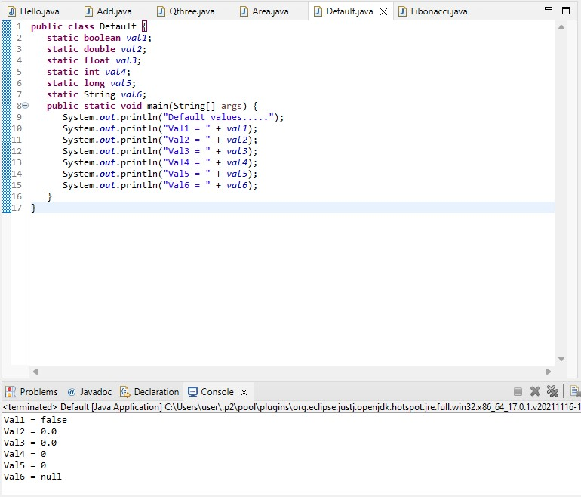

Q6. Print Fibonacci series till n

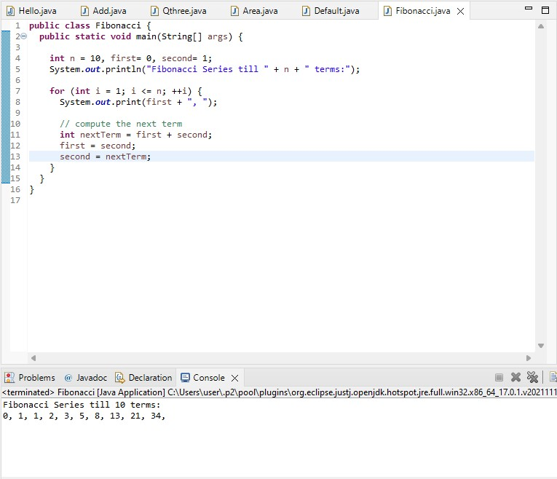

Session - 2

Q1. Check if a number is palindrome or not

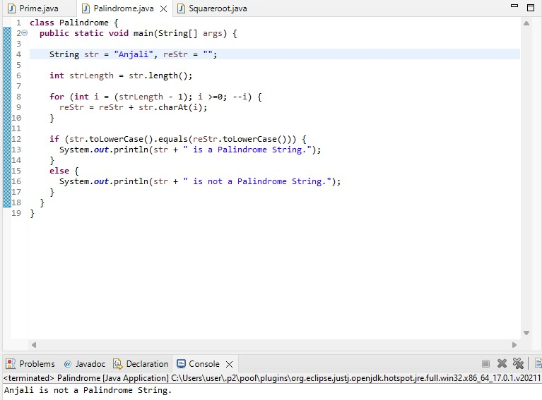

Q2. Display prime numbers between 1 and 100

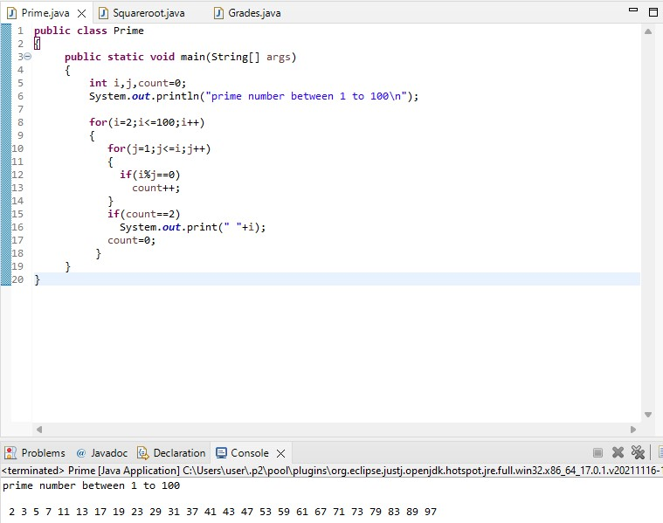

Q3. Find the square root of a number without sqrt method

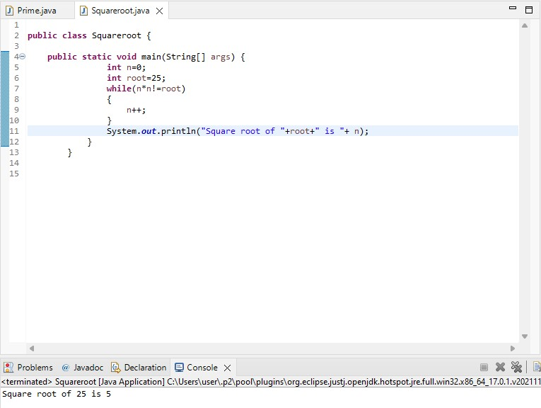

Q4. Calculate grades of students using their marks

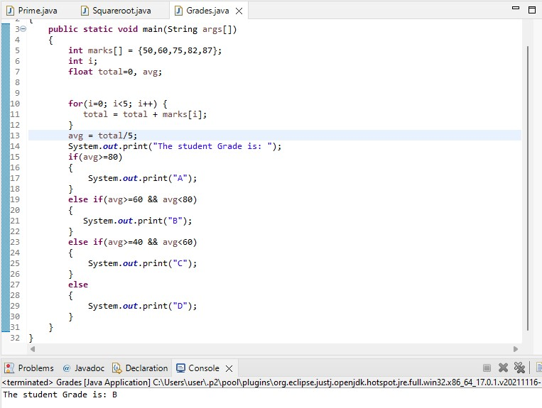

Q5.Calculate grades of students using their marks

